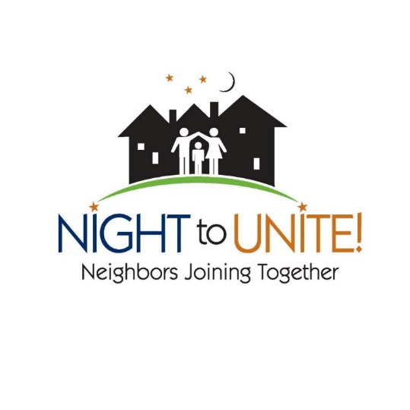

Party Planning Checklist

Task | Who | When | How much | Notes
Determine time and location
Pick alternate location if needed
Register event with City |  |  | Free | edenprairie.org/NightToUnite
Distribute “Save the Date” cards
Plan how others can contribute | (Bring a dish to share, bring your own, bring your own grill item, contribute money)
Plan activities for children and adults
Coordinate food drive for PROP in conjunction with your event
Distribute invitations, hang posters
Plan food
- Appetizers, munchies
- Salads
- Meals
- Desserts
Plan beverages
- Water
- Child beverages
- Adult beverages
Bring supplies
- Name tags
- Tables/table cloths
- Chairs (or bring your own)
- Plates, cups, napkins, silverware
- Garbage can(s)
- Grill, fire starter
- PROP donation sign and bin
- Prizes/giveaways
- Decorations
Clean up after event

